January 15, 2024

Chaya stern & Racheli REICH

mcon 353

Documentation For ITPS Fall 2023

a ticketing application

**Application Overview**

* This application is a ticketing website. It tracks tickets for different departments. Users can view tickets assigned to them, add new tickets or edit existing tickets.

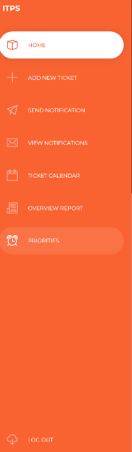**Side bar (figure 1a)**

Figure 1a

Figure 1b

* 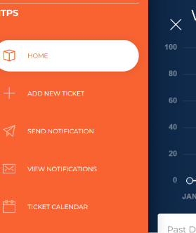**On the side of each page there is a menu for the user to choose from. The menu contains a list of all the pages. The pages are home, add new ticket, send notification, view notifications, ticket calendar, overview reports, priorities, and logout.**

Figure 1c

* **When the user is using a smaller view window, he can click on the hamburger lines on the top left-hand side and the menu will show up on the side (figure 1b). There will be an x where the hamburger lines were (figure 1c).**

**Dashboard (figure 2a)**

Figure 2a

* 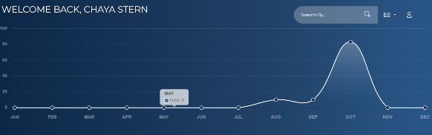**The dashboard** shows up at the top of each page. On the top it says Welcome Back and then the users name. The main component of the dashboard is a graph that shows the number of tickets the user had per month.
* 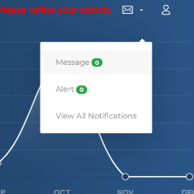**In the top left-hand corner of the dashboard there are a few things the user can do.**

Figure 2b

* **One of the options is an envelope. When the user clicks on the envelope there is a small list of options. The options are message, alert, and view all notifications. Messages and alerts have a number next to them which tell you how many of each exist. When you click on any of the three you are taken to the view notifications page. When the user selects messages or alerts the messages and alerts are filtered on the view notification page (figure 2b).**
* **The search bar allows the user to search for a ticket. The user can type in the ID number of the ticket, or enter a string from the short/long description. It will route the user to the Add New Ticket page, with the details of the tickets. If 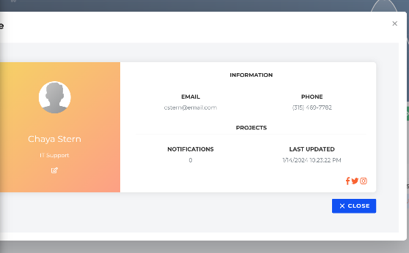no ticket is found, or more than one ticket is found, there will be an error message.**

Figure 2c

* **Another option is a profile button. When the user clicks the profile button a pop-up window appears with the user’s information. It has the user’s picture, name, job, email address, telephone number, and activity. There is a close button on the bottom the user can click to close the window (figure 2c).**

**Home (figure 3a)**

Figure 3a

* 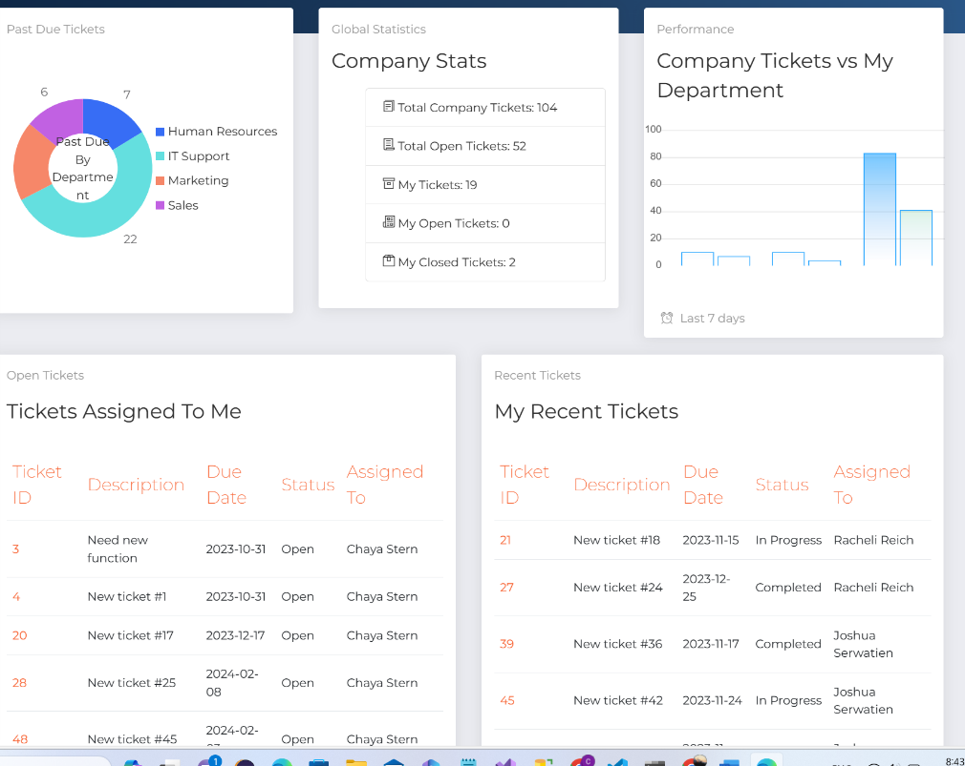**Once the user logs in to the website the user will view a home page with a dashboard of graphs representing the company, department, and user data.**
* **Past Due Tickets- The user will see a pie chart graphing the number of overdue tickets by department. The departments are human resources, IT support, marketing, and sales. They are represented by the colors blue, green, orange, and pink.**
* **Company Stats- The user will see a list of global statistics for the entire company and for the user himself. The stats are the total number of company tickets, the total number of open tickets in the company, the number of tickets the user has, the number of open tickets the user has, and the number of closed tickets the user has.**
* **Company Stats- The user will see a list of global statistics for the entire company and for the user himself. The stats are the total number of company tickets, the total number of open tickets in the company, the number of tickets the user has, the number of open tickets the user has, and the number of closed tickets the user has.**
* **Tickets Assigned to Me- The user will see a grid containing information about the user’s open tickets. The first column of the grid is the open ticket’s ticket ID, the next column is the description of the Ticket, the next column is the status, and the next column is assigned to.**
* **A screenshot of a computer

  Description automatically generatedMy Recent Tickets- The user will see a grid containing information about the user’s recent tickets. The first column of the grid is the ticket ID, the next column is the description, the next column is the due date, the next column is the status, and the last column is assigned to.**

Figure 4a

* **The IDs in both, Tickets Assigned To Me, and My Recent Tickets is a link to the Add New Ticket page where users can view that tickets information.**

**Add New Ticket (figure 4a)**

* This page allows the user to enter a new ticket.
* In the description box, the user can enter the ticket’s priority, a number from zero to ninety-nine.
* Below the priority box, there is a placeholder where the user enters a short description of the ticket, and beneath that, a longer description.
* A screenshot of a computer

  Description automatically generatedTo the right , there is a status box. The user can select the tickets due date from a date picker, and then assign the ticket to an employee from the dropdown box. If the user chooses, they can choose to assign the ticket to everyone.

user can edit the survey, using the ‘Edit’ link

Figure 4b

* By pressing the green save button below the status box, the ticket will be saved to the database.
* If a ticket is clicked on in the Open Ticket grid or the recent ticket grid, the link will navigate them to this page. The ticket details will be displayed on the page. The user can edit the ticket and save it (figure 4b).
* Below the description box, there will now be a Status History box which shows the history of the currents tickets status. What the status was, what it was changed to, who updated it and when.
* To the right there is a notes box, in which the user can enter a note about the ticket. The grid displays all notes for A screenshot of a computer

  Description automatically generatedthat ticket and who entered the ticket when. There is a garbage bin option that allows users to remove the note.

if the survey was never taken, ‘Take the Survey’ will be displayed

* In the top right corner of the page, there is a section for a survey. If the survey was never taken, ‘Take the Survey’ will be displayed. Otherwise, the survey average will be displayed with a progress bar beneath it, displaying the average. The user can edit the survey, using the ‘Edit’ link

**Ticket Survey** (figure 5a).

Figure 5a

* The purpose of this page is for the user to rate the support they received with their ticket.
* There are three questions each one with possibility of rating up to five stars, and optionally add a comment.
* This page is accessed from the Add New Ticket page when an existing ticket is loaded in

Figure 6a

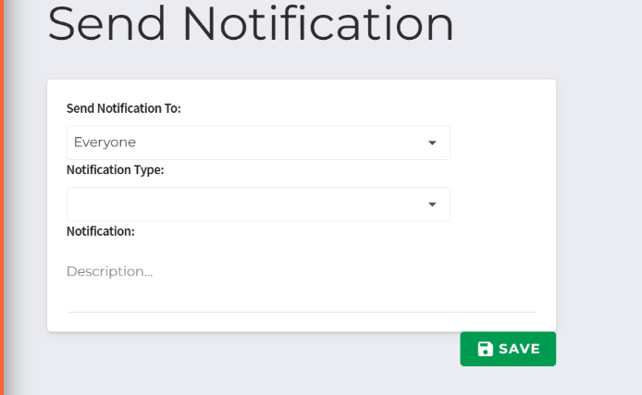Send Notification (figure 6a)

* When the user clicks on the send notification tag a new page shows up with a form. The first row on the form is send notification to. There the user chooses from a dropdown menu consisting of Chaya Stern, HR user, everyone, Joshua Serwatien, Rachel Reich, Marketing user, and sales user. The next row is Notification type, and the user chooses from a drop down menu consisting of just two choices, alert and message. The last row is Notification, and the user can input the description of the notification. When done filling out the form the user clicks save, and the notification is sent.

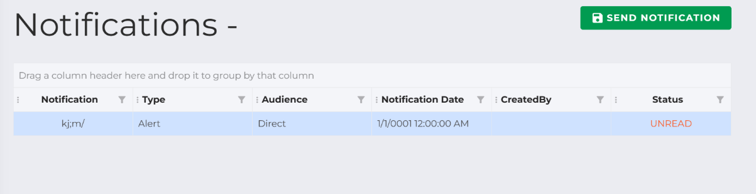View Notification (figure 7a)

Figure 7a

* The user can view his personal notifications on this page.
* On the top right-hand side of the page under the dashboard there is a button called send notification. When the user clicks the button, he is brought to the send notification page.
* 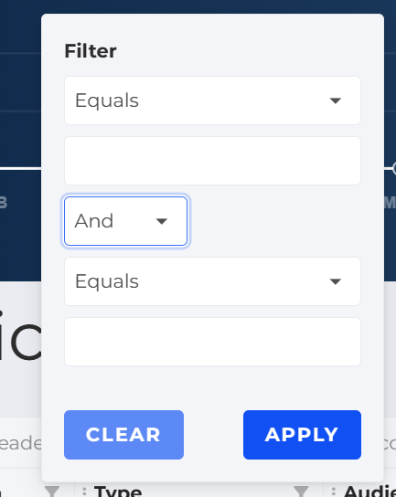There is a grid with different columns for different pieces of information about the notification. The column names are notification, type, audience, notification date, created by, and status.

Figure 7b

* Next to each column’s name the is a button you can press to filter the returned data. When pressed a pop-up window appears (figure 7b).
* The pop-up window is a menu with three drop down boxes. In the first drop down box the user can choose from a list of options which are equals, not equals, less than, less than or equals, greater than, greater than or equals, in, notin, null, is not null, and custom. The third drop down box is the same as the first and they both have a text input box beneath them. The middle drop-down box is and or or.
* There are two buttons on the bottom of the form one is apply and the other is clear.

Figure 8a

Ticket Calendar (figure 8a)

* The purpose of this page is to help the user keep track of their tickets, and when they are due.
* Each ticket is displayed on their due date on the calendar. If it’s due in the next five days it’s yellow, if it’s overdue it’s red, and if it’s neither it’s blue. The current date on the calendar is green.
* If the user clicks on a ticket in the calendar, it will bring them to the Add new Ticket page, with it’s details filled out.

Figure 8b

* 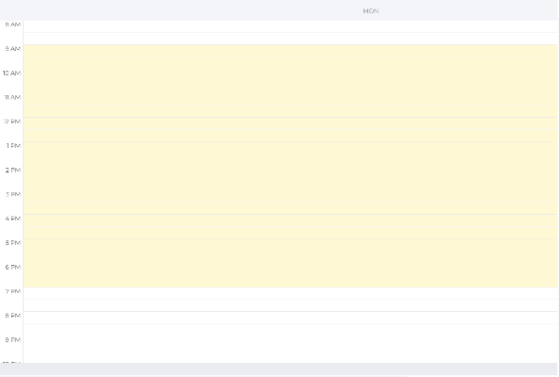When the user first clicks on this page he sees a monthly calendar. The user can navigate from one month to the next with the arrows at the top left-hand side of the page under the dashboard, Next to the arrows there is a button that says today which the user can click to return to the current day.

Figure 8b

* On the top right-hand side of the page there are different options the user can choose from. These are day, week, month, and year.
* The day page shows the hours and if anything is assigned to any hour of the day (figure 8b).
* The week page shows the hours for all seven days, and what is assigned to each day.
* The month page just shows the day and not the hour and what is assigned to that day.
* 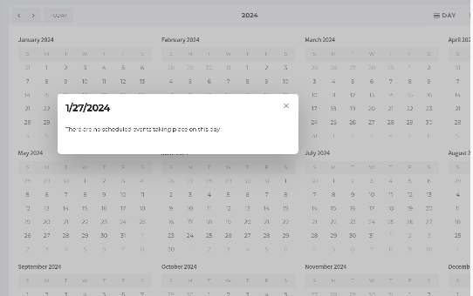The year page shows small calendars for all twelve months. You can only see the date. But when you click on a date a window pops up telling you if anything is assigned (figure 8c).

Figure 8c

**Overview Report(figure 9a)**

Figure 9a

* This page is an overview of all tickets in the system.
* The Chart on the top left is a bar chart that indicates to the user how many tickets each department has. When the user hovers over a bar on the chart, the department name and number of tickets is displayed.
* On the left-hand side of the chart there is a key, that shows which color bar chart is for what department.
* **A screenshot of a computer

  Description automatically generatedA screenshot of a computer

  Description automatically generatedA screenshot of a computer

  Description automatically generated**On the right side of the page there is a section called “Filter Bank,” where the user can create filters to display tickets in the gird below. The user can select a range of dates, and whether to show open, closed or all tickets (figure 3b, 3c, 3d).

Figure 9c

Figure 9b

Figure 9d

* A screenshot of a computer

  Description automatically generatedA screenshot of a computer

  Description automatically generatedA screenshot of a computer

  Description automatically generatedOn the bottom of the page is a data grid that displays all the tickets returned, based on the filter bank. The grid shows all relevant information to the ticket such as its key, description, priority, date entered, status, who its assigned to and the department. In the top right corner of the grid, there is a dropdown box, where the user can select which columns to show and which ones to hide(figure 3f). Further, each column has a filter where the user can filter the data in that column (figure 3e). Lastly, the user can drag any column to the grids header and the grid will group on that column (figure 3g). This is ideal, if a user wants to see what tickets were entered on each date, or the tickets by their status.

Figure 9f

Figure 9g

Figure 9e

**Priorities (figure 10a)**

* The purpose of this page is to display to the user all of their A screenshot of a computer

  Description automatically generatedopen tickets, ordered by priority. It allows the user to enter a new priority level for the ticket.

Figure 10a

* The grid displays relevant data to the tickets, such as the key, description, assigned to, due-date, status and priority.
* The user can select the columns that are showing from the drop-down box on the top left of the grid (figure 3f).
* When a priority is changed, the grid resorts according to priority, with the highest priority appearing on the top.
* Further, each column has a filter where the user can filter the data in that column (figure 9e).
* Lastly, the user can drag any column to the grids header and the grid will group on that column (figure 9g).

Figure 11a

Log Out (figure 11a)

* 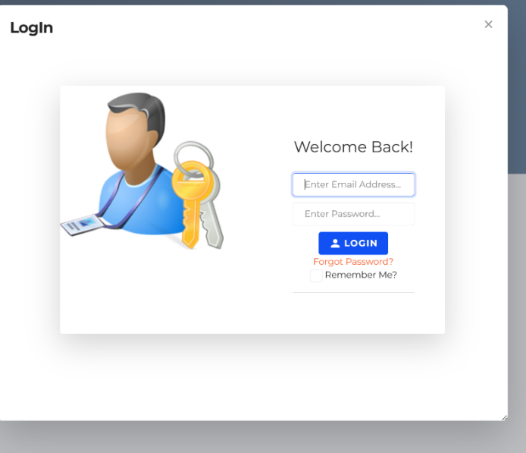When the user clicks on the logout page he is logged out and taken to the login page.
* The login page asks the user for the username and password and then has a login button. There is also a forgot password option and a remember me checkbox.